Half-Mile Posts, Alabama and Florida
A Federal Perspective

As happens from time to time, an obscure aspect of the Public Land Survey System (PLSS) is brought to the forefront of scrutiny; debates ensue based upon various levels of understanding of the history and facts of the matter. The background and chronology that follow is intended to put the subject of Half-Mile Posts into its proper context. It can be a start for anyone wishing a more comprehensive understanding of the subject.

History and Administration of the PLSS

What is the Public Domain?
After the American Revolution, seven of the original thirteen colonies claimed the unsettled “wild” lands between the Allegheny Mountains and the Mississippi River.
These seven colonies ceded their claims to this area to the newly confederated United States under the terms of the October 10, 1780, resolution of the Continental Congress.

The resolution stated that the ceded lands were to be utilized for the common benefit of all the people of the Confederated Colonies. They were to be disposed of or settled under such rules and regulations as agreed upon by the United States in Congress assembled.

The colonial sessions included the Territory south of the State of Tennessee, now Alabama and Mississippi, and the Territory northwest of the Ohio River, now the states of Ohio, Indiana, Illinois, Michigan, Wisconsin and the eastern portion of Minnesota. The lands ceded by the colonial states were from that time on referred to as:
“The United States Public Domain.”

About 1.5 billion acres of land were added to the U.S. Public Domain when territories west of the Mississippi River, Florida, and Alaska were acquired by the United States.

The legal foundation for the PLSS
In 1780 the Congress of the Confederated States passed a resolution reserving to itself the right to dispose of the Public Lands and to make the rules for the means of its disposal.
Terms of the 1780 resolution are incorporated in Article IV, Section 3 of the United States Constitution which says:

“The Congress alone shall have the power to dispose of and make all needful rules and regulations respecting the territory or other property belonging to the United States; and nothing in this Constitution shall be so construed as to prejudice any claims of the United States, or of any particular State.”

The specific act of Congress most germane to the half-mile post situation and the proper treatment of them is the Act of February 11, 1805.

Administration
The administration of the Public Lands, including surveying, was placed under the Secretary of the Treasury an appointee of the President. The Act of May 18, 1796 called for the appointment of the first Surveyor General, also a presidential appointee. The business of the Public Land administration became an overwhelming task for the Secretary, and in 1812 the General Land Office (GLO) was created within the Department of the Treasury. A Commissioner, also appointed by the President, headed the GLO.

The Treasury Secretary, the GLO Commissioner and the Surveyors General had to work closely together in dealing with the Public Land Surveys. These men were on equal footing, all having been appointed by the President. The Secretary and the GLO Commissioner had limited power over the Surveyors General. As new Surveyors General were appointed, control was exercised through the monies appropriated by Congress for the Public Land Surveys. These men, much like surveyors today, all had opinions on how to carry out the various Acts of Congress relating to the Public Land Surveys. If the Secretary or Commissioner didn't agree with a particular Surveyor General, they simply adjusted the amount of funds he received. This form of control had limited impact because the Surveyors General had equal access to the President.

Surveyors General
The first Surveyor General was Rufus Putnam, appointed November 5, 1796. He was responsible for the surveys in the Northwest Territory (the lands northwest of the Ohio River).

The second Surveyor General was Isaac Briggs, appointed April 1, 1803. He was responsible for the surveys south of the State of Tennessee (now Alabama, Mississippi and Louisiana after its purchase in 1803).

Seth Pease was appointed in 1807, replacing Briggs as Surveyor General for the lands south of the State of Tennessee.

Thomas Freeman succeeded Pease as Surveyor General for the lands south of the State of Tennessee with his appointment on September 10, 1810.

Edward Tiffin was the first Commissioner of the GLO from May 7, 1812 to October 11, 1814. He was also the fourth Surveyor General for the Northwest Territory, appointed in November of 1814.

Alabama was split out of the jurisdiction of the lands south of the State of Tennessee with the appointment of John Coffee as Surveyor General of Alabama in March 17, 1817.

Each of these Surveyors General was authorized to frame regulations and instructions for the direction of the deputy surveyors within their surveying districts. History shows that some did and some didn’t provide guidance, as evidenced by the written instructions that have survived. As stated above, they all had opinions as to carrying the Federal laws into effect, which explains the different methods of survey in the various jurisdictions.

Similarities can be explained by the fact that some of the Deputy Surveyors who later became Surveyors General had previously worked under or with other Surveyors General. For example, Coffee worked for Freeman who had worked for Pease. As documented by the field notes, contracting Deputy Surveyors migrated with the work. Deputy Surveyors who had worked in Mississippi and Alabama wound up with contracts in Florida. One can easily surmise that an experienced Deputy Surveyor from Alabama with a contract from Robert Butler, (the first Surveyor General of Florida appointed July 9, 1824) who never issued any general instructions of his own that we know of, executed his surveys in the same fashion as he had in Alabama. Even if Butler objected to the returns when he received them, he was hardly in a position to force the Deputy Surveyor to correct them as he had issued no general or specific instructions to the contrary and the Deputy’s former work, done in the same fashion, had been accepted.

An understanding of this early history and administration serves to explain how the practice of setting half-mile posts could exist in one area of the country and not another, and how this practice may have migrated to Florida.

The Origins of Half-Mile Posts

Where and when did this practice actually start?
We know from the field notes that few half-mile posts exist in Mississippi; many exist in Alabama, and some in Florida. To my knowledge, they are not found in any other township subdivision notes in any other part of the country. They do, however, exist in long straight-line segments of old Indian boundary surveys.

A glimpse into the possible true origins of the half-mile post is provided from research done by Mr. Lane Bouman, BLM Eastern States Deputy State Director for Cadastral Survey, retired. For many years Mr. Bouman studied various correspondence records between Surveyors General and the Secretary of the Treasury and the Commissioner of the GLO.

The following quotes were found by Mr. Bouman in correspondence between Seth Pease, Surveyor General for the lands south of the State of Tennessee and the Secretary of the Treasury.

Letter dated July 14, 1807 to the Secretary of the Treasury from Seth Pease:
“Mr. Thomas Freeman is on his way from this place (Washington, Mississippi Territory) to the Tennessee river, in order to run the boundary lines of the Chickasaw session…”

Letter dated August 19, 1808 to the Secretary of the Treasury from Seth Pease:
“Mr. Thomas Freeman has returned the notes of four Townships and informs me that he expects to complete the survey in the bend of Tennessee this season.”

Letter dated May 31, 1809 to the Secretary of the Treasury from Seth Pease:
“I have the honor to transmit … the Townships of the Public Lands in Madison County M. T. from the field notes of Thomas Freeman and …”

Letter dated August 2, 1809 to the Secretary of the Treasury from Seth Pease:
“I mentioned in my instructions to Mr. Thomas Freeman that the law required a post be set at each half mile for the corners of sections, or rather that it be placed just half way on each line between the corners of sections as run…”

Letter dated October 25, 1809 to the Secretary of the Treasury from Seth Pease:
“Mr. Thomas Freeman informs me that he has set half mile posts on all his lines in his survey of Madison County, but that they will not always be found exactly half way between the section corners. I can furnish the Deputy Surveyor for that District with instructions for placing any one correctly which may not be so, without giving him any extraordinary trouble.”

Mr. Freeman, being an experienced Indian boundary surveyor, obviously carried the terminology and practice of setting half-mile posts into the subdivision of townships.

Looking at Mr. Pease’s side of the correspondence, it is easy to conclude that the Secretary must have had some concerns with the half-mile posts set by Mr. Freeman.
No other correspondence on the matter has been discovered and Mr. Pease’s remedy was never done. So the practice of setting half-mile posts, although questioned in 1809, was never corrected; and in fact, as evidenced by the field notes, was continued throughout Alabama and carried into Florida.

It has been suggested that Mr. Tiffin’s instructions of 1815 could be viewed as being written to “kill off” half-mile post procedures. As seen above, the issue had arisen as early as 1809, some 3 years prior to his first involvement with the Public Land Surveys as Commissioner of the GLO. One could postulate that because of Tiffin’s stint as GLO Commissioner, he was undoubtedly aware of these half-mile posts and given the obvious learned nature of the man, he could foresee the vexing problems that could result because of them.

Because of his experience as GLO Commissioner, Mr. Tiffin was surely aware of the lack of uniformity in the surveys being executed; and when he was appointed to the office of Surveyor General for the Northwest Territory, he developed his own detailed instructions as an effort to ensure uniformity in the future. He was also aware, however, that his instructions had no force and effect beyond his jurisdiction, the Northwest Territory.

The Controversy with Half-Mile Posts

What half-mile posts are and how they came to be is succinctly described in the first two paragraphs of Section 5-39 of the 1973 Manual and is quoted here.

“5-39. “Half-Mile Posts,” Alabama and Florida
In the early practice in parts of Alabama and Florida, so-called “half-mile posts” were established at distances of 40 chains from the starting section corner. The term was applied where the line might be more or less than an exact 80 chains in record length, and where by later methods the latitudinal lines have been run as “random and true.” The practice contemplated that in some cases these subdivisional lines be run in cardinal directions to an intersection, where the next section corner would be placed, and either or both lines might be more or less than 80 chains in length. In some cases the section corners were placed across the township at intervals of 80 chains on one of the cardinal lines, and the other lines were run on random only. On the first plan the “half-mile post” would not be at midpoint unless the line turned out to be 80 chains in length. On the second plan the “half-mile post” on the lines first run would be in true position for the quarter-section corner, but on the lines last run they would usually not be on true line, nor at midpoint.

In both cases field notes were written showing a true line direction and midpoint distance
for a quarter-section corner. This was done to meet the objection that the “half-mile post” did not satisfy the requirements of law, but the true line was not actually run on the ground, nor was a monument constructed at midpoint. In these cases only the true line field notes need be regarded if the evidence of the “half-mile post” has disappeared; but where the latter can be identified the point must be given proper weight for control. Each set of field notes requires its individual consideration, as the practices were not uniform even in the same surveying district.”

The intersection method of establishing the next section corner, which resulted in one or both lines being more or less 80 chains long, comes directly from instructions to Deputy Surveyors issued by John Coffee, Surveyor General of Alabama, dated May 4, 1817. Note that Coffee had been a contracting Deputy Surveyor for Freeman whose work had been questioned by Secretary Albert Gallatin in 1809.

The crucial problem with these half-mile posts is the fact that in most cases, they failed to satisfy the law.

Pertinent requirements of the Act of February 11, 1805
“1st. All the corners marked in the surveys, returned by the Surveyor General shall be established as the proper corners of sections, or subdivision of sections, which they were intended to designate; and the corners of half and quarter sections, not marked on the said surveys, shall be placed as nearly as possible equidistant from those two corners which stand on the same line.”

This is where the problem with the half-mile post begins. Some will point to this requirement in the statute and say that it doesn’t matter where the half-mile post is.
If it can be recovered, it is controlling, after all it’s an original corner.

“2nd. The boundary lines, actually run and marked in the surveys returned by the
Surveyor General, shall be established as the proper boundary lines of the sections, or subdivisions, for which they were intended, and the length of such lines, as returned, shall be held and considered as the true length thereof. And the boundary lines, which shall not have been actually run, and marked aforesaid, shall be ascertained, by running straight lines from the established corners to the opposite corresponding corners; but in those portions of the fractional townships, where no such opposite corresponding corners have been or can be fixed, the said boundary lines shall be ascertained, by running from the established corners due north and south or east and west lines, as the case may be, to the water-course, Indian boundary line, or other external boundary of such fractional township.”

The boundary lines actually run and marked being established as the proper boundary becomes a key consideration in the technical treatment of a recovered half-mile post.

“3rd. Each section, or subdivision of section, the contents whereof shall have been, or by virtue of the first section of this act, shall be returned by the Surveyor General, shall be held and considered as containing the exact quantity, expressed in such return or returns; and the half sections and quarter sections, the contents whereof shall not have been thus returned, shall be held and considered as containing the one half, or the one fourth part respectively, of the returned contents of the section of which they make part.”

The latter part of the 3rd subsection of Sec. 2 of the Act means that if the Surveyor General did not indicate by protracted subdivisions or lottings of the sections on the plat, the only division of the section allowed by the statute would be by aliquot part of the whole. This portion of the statute is the reason for Section 7-10 of the current Manual.

Most of the surveys in Alabama and some in Florida do not contain any protracted section subdivisions or any of the customary lottings. This is true even on sections closing into the township exterior. Many of these closing miles were considerably short or long of 80 chains going into the boundary, yet the half-mile posts were set at 40 chains from the starting section corner. In these instances, the lands were patented by one-fourth or one-half of the returned acreage for the entire section. This clearly indicates that the half-mile post, although set in the original survey, was not held as a controlling corner for the subdivision of the section.

Let’s look at some actual records to better see the situation.

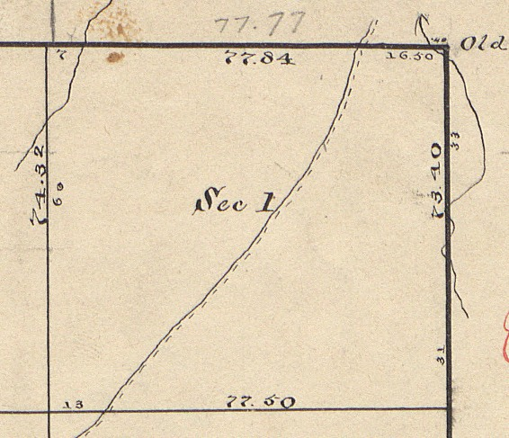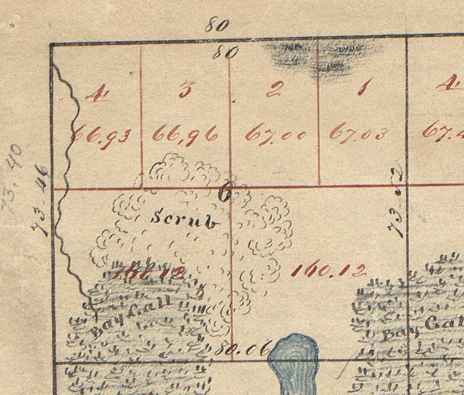
Section 1, T. 15 S., R. 23 E., Tall. Mer., FL. Section 6, T. 15 S., R. 24 E., Tall. Mer., FL.

Protracted subdivision and lot lines with acreages were returned on the plat by the Surveyor General for Section 6. In contrast, Section 1 in the abutting township has no protracted subdivision lines; and only the acreage of the entire section (573.68 acres) was returned. 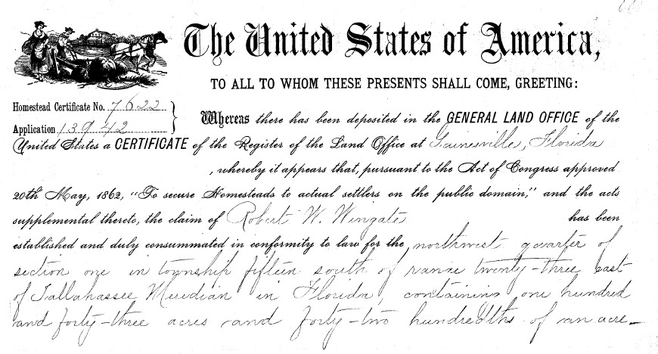
Portion of the Patent for the NW¼ of Section 1, T. 15 S., R. 23 E., Tall. Mer., FL.

The patent for the NW¼ of Section 1 is for precisely one fourth the total acreage of Section 1 returned by the Surveyor General (143.42 acres). Patents for Section 6 were with specific reference to the lotting and areas as returned on the plat by the Surveyor General. These patents are in complete accord with the statute.

The official field notes of these surveys show that half-mile posts were set at 40 chains from the south on the west boundary of Section 1, the east boundary of Section 6 and on the range line common to both sections.

Everything is fine up to the point the sections are to be subdivided on the ground.
There is generally no problem with Section 6 because the Surveyor General by his protraction and lotting made the original half-mile posts controlling for the subdivision. His protraction and lotting, in accordance with the statute, controlled the descriptions in the patents issued. Section 1, however, becomes a dilemma for some because according to the same statute, original monuments control.

The concept that original corners control has been ingrained in surveyors early on and throughout their careers. So much so, that recognizing there are exceptions becomes difficult. Our example here is even further compounded with the common knowledge among surveyors that the overage or shortage that exists in these surveys is by Federal law and Manual requirement to be placed against the north and west boundaries of the townships. In so doing, as many regular aliquot parts of the closing sections as possible are created. The Surveyor General’s protraction of Section 6 with nominal 160 acre aliquot quarter sections in the south half and the four lots in the north half demonstrates this requirement.

Another element of confusion is where the Manual discusses subdivision of sections by protraction and by survey in chapter three. This chapter deals with original and completion surveys of vacant Public Land. The guidance for subdivision by protraction is for cartographers creating the plats that will be the basis for patenting. It has no merit for subdividing sections once any or all of the land in a section has been patented.

As a consequence today, most surveyors’ initial approach to Section 1 is to hold the original half-mile posts to control the subdivision of Section 1 as well. The result being that the patentee for the NW¼ of Section 1, having legally acquired it in good faith under the law, is by a survey process denied 16.58 acres of the 143.42 acres patented. Conversely, patentees in the south half of the section have their acreage enriched by 16.58 acres. It could easily be argued that this subdivision of Section 1, amounts to a taking without compensation and as such is unconstitutional.

The graphic below demonstrates the incongruity of the result.

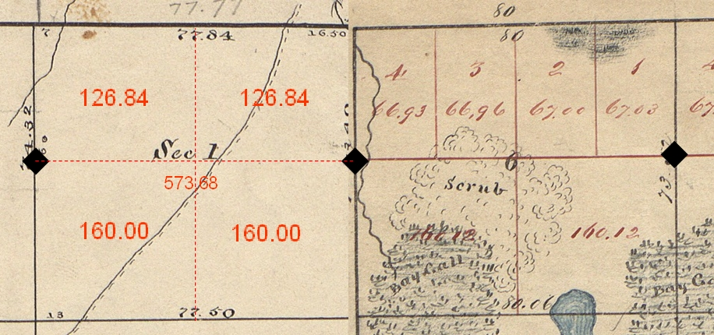

With a little deeper consideration of the entire Act of February 11, 1805, in the context that it included elements applicable to the disposal of the Public Lands as well, one should recognize that there are instances when the patent records dictate the proper subdivision of sections.

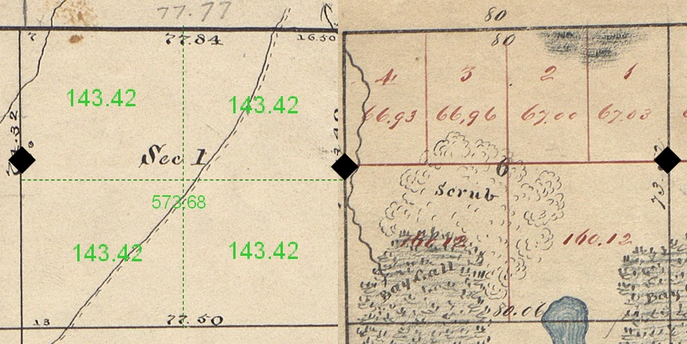

The above shows the subdivision of Section 1, using the midpoint or equidistant principle from the Act of February 11, 1805, protecting the patents that contained ¼ of the total returned acreage as also specified by the same statute.

Hopefully, this serves to demonstrate that an original half-mile post, albeit an original corner set in the course of the original survey, represents an exception to the rule that original corners control.

Half-mile posts were not, in effect, the equivalent of original quarter section corners. They can only be used to control the subdivision of sections if by clear implication they were used to protract the subdivision of the section; or if by record they are, in fact, equidistant or midpoint between the section corners of the same line.

The Act of February 11, 1805 stipulates that a quarter section corner was to be established, as near as may be, equidistant between the corners of the sections on the same line. Understanding Coffee’s instructions and the common practice of setting these half-mile posts going back to Freeman’s 1809 work, it is easy to see why they were generally not considered as marking the quarter section corner; they simply in most cases, did not meet the legally established requirement.

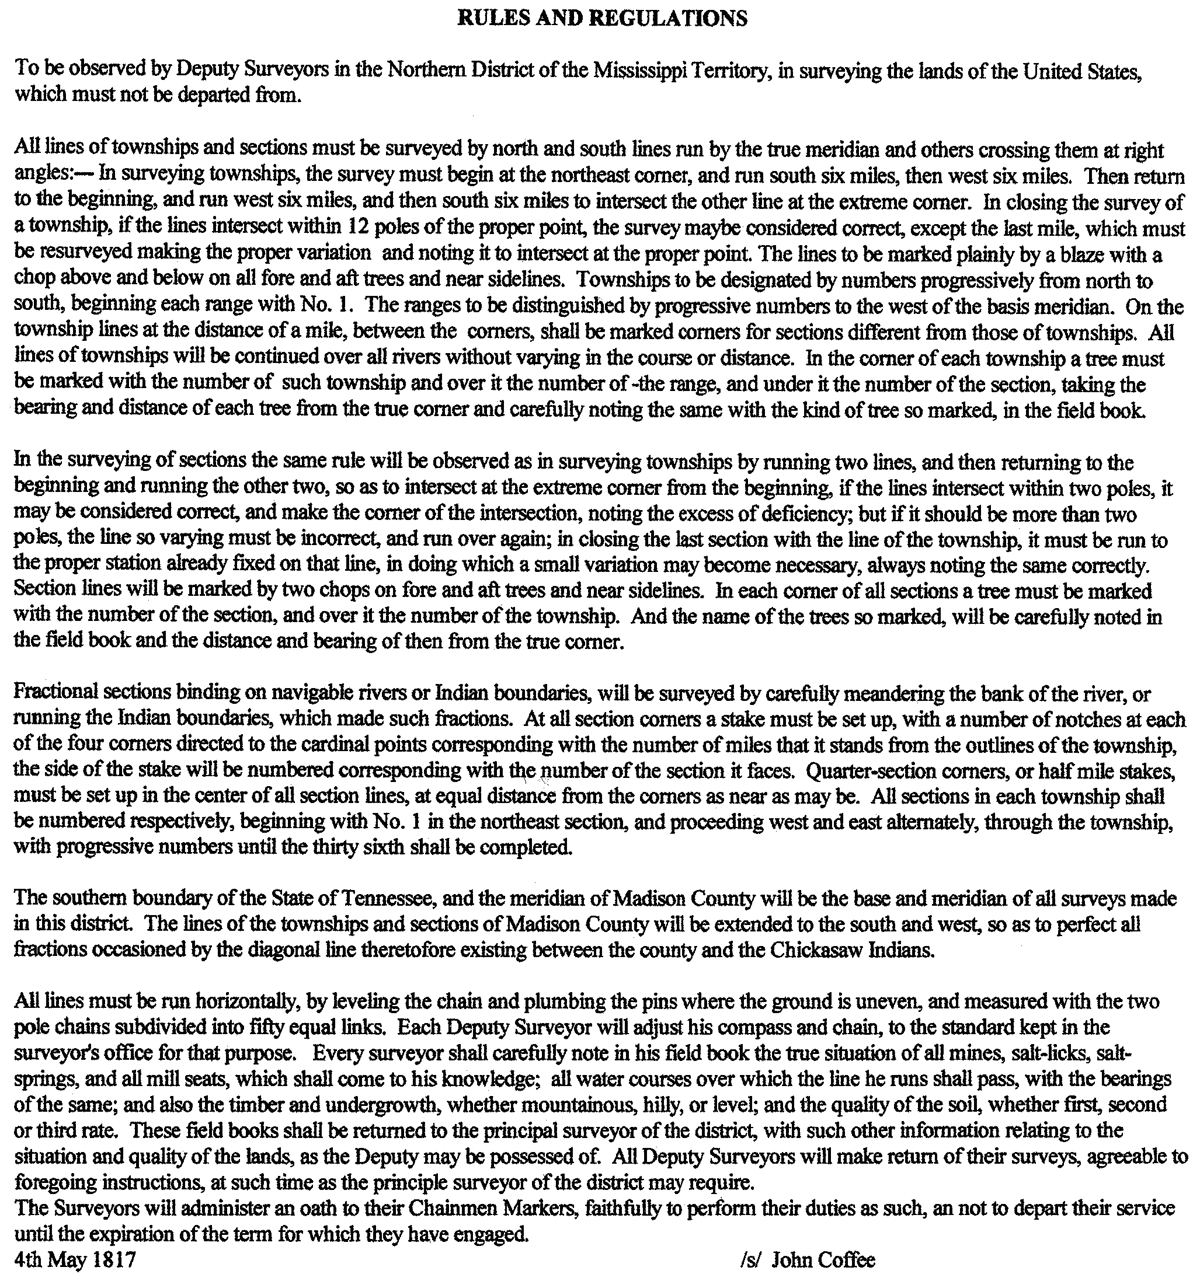
The Manual Treatment of Half-Mile Posts

Starting in 1809 with Treasury Secretary Gallatin’s objections to the half-mile posts set by Freeman, the GLO beginning in 1812 and later the Bureau of Land Management (BLM) since 1946 has taken a consistent position in regard to the half-mile posts. It should be acknowledged, considering the early nature and limited scope of half-mile posts, that there simply hasn’t been much written officially on the subject.

The following is quoted from the Restoration of Lost or Obliterated Corners, a Circular of the Department of the Interior, General Land Office, Washington, D. C., Revision of June 1, 1909. It is believed to be the first official Manual or Circular mention of half-mile posts:

“61. Note.- In some of the southern public-land States it was the custom in the early surveys to establish half-mile posts at a distance of 40 chains from the point from which the section line was initiated, at the same time inserting in the field notes at the midway point ”1/4 sec. cor.” without indication in the field notes that any other corner than the half-mile corner was set. And it is presumed that the ¼ sec. cor. was merely “called for” at that place. This practice has long been discontinued owing to the confusion thereby occasioned.

These half-mile posts have no bearing upon the subdivision of the section except where they happen to occupy the midway point on true lines between section corners. In such cases, when a subdivision is required of a section surveyed on this plan, and no original quarter corners are found, the latter should be reestablished at a point on a true line midway between the original section corners.”

The GLO and BLM have not varied from this viewpoint for nearly one hundred years as it is based on Statutory Laws. Any rule or regulation published in a technical bulletin by an administrative agency is null and void when it is in conflict with the law.

Not until 1947 were procedures for dealing with recovered half-mile posts incorporated into the Manual of Surveying Instructions. These procedures are binding upon the Cadastral Survey employees of the Bureau of Land Management in the course of conducting dependent resurveys on Federal lands. Any surveyor surveying private lands that abut Federal lands should also adhere to them.

The fourth rule relating to half-mile posts in Section 5-39 of the 1973 Manual of Surveying Instructions could be argued to be in violation of the Act of February 11, 1805.

The Act of February 11, 1805 stipulates that the section line as run and marked will be the true boundary. This fourth rule forces the angle point in the section line, if one exists, to be at the quarter section corner placed at the record correction from the original half-mile post.
Although admittedly a minor detail, this places the quarter section corner off the original line. If there was an angle point in the original line, it would have been at the half-mile post.

The author of the 1973 Manual Mr. Thomas Tillman was asked about this minor deficiency. Mr. Tillman was well aware of the objection to the procedure and explained that it was preferable because you would have to re-monument the half-mile post and the quarter section corner to preserve the original section alignment. Having two monuments so close together was judged to be too confusing; a procedure that placed the angle point at the quarter section corner, even if it was ever so slightly off the true line, was preferable.

The fourth rule under Manual Section 5-39 also requires the record correction for distance to be applied. This stems from the premise, if the original surveyor would have set the corner that is where he would have placed it. This theory has some merit; however, one can easily see where this notion could be totally in error.

Take for example, the placement of a sixteenth section corner, not set in the original survey, on a line closing into a former boundary i.e. a township line. See Section 5-41 of the Manual. This section of the Manual requires the use of the position of the offline closing corner, as opposed to the true intersection, to establish sixteenth corners not monumented in the original survey. It is likely that you could come up with a situation where the closing corner is so far off the senior controlling boundary that using this procedure would place the position for the sixteenth section corner over the said boundary as well. This would, in effect, eliminate or, if not over the senior boundary, severely diminish a lot that exists on the original plat.

No one today has the authority to dictate procedures, be it the treatment of half-mile posts or the establishment of minor corners not set in the original survey, if said procedures can be shown to impair a right properly granted under the authority of the Constitution. The diminished right could be argued as a taking without just compensation and that is clearly unconstitutional. I’m more inclined to following the Act of 1805 as strictly as possible.

Case Law Concerning Half-Mile Posts

The status of an original half-mile post, not set equidistant in accordance with Federal Statute was considered by the Supreme Court of Alabama in Walters v. Commons,
2 Port. 38; 1835 Ala.

Quoted Sections of Walters v. Commons
“Walters was owner of the south east quarter of section eight, in township eighteen, of range ten, and Commons claimed the east half of the south west quarter of the same section. The whole section was found to contain six hundred and fifty two 37-100 acres, and the question raised in this case, was, in substance, whether the surveyors had the right of removing the half mile posts, and of thus giving the plaintiff his portion of the excess in the section. The Court below, charged, among other things, that the surveyors had no right to remove the half mile stakes, if without doing so, they could give the quantity called for in the patent, though the section contained more than six hundred and forty acres. There was a judgment for defendant below, and the plaintiff having excepted to the opinion of the Court, took his writ of error.” …

“The titles to lands in this state, are derived from grants by the United States, and are made under surveys regulated by laws of the United States.”…

“... It is only when there is an error in not placing the half mile post or corner at the center of the line of the section, that the inequality occurs. By law, these corners are not declared to be "established as the proper corners," as is done in the case of sections; to disturb which would distract a whole township: but they are to be as "nearly equidistant as possible from the corners of the section;" and if there is an error found in that particular, by which one person owning one half or quarter of a section, has got possession of more than the half or quarter, it is the opinion of the Court that this error can be corrected.”

So the Alabama high court is saying the record establishment of the half-mile post is immaterial, if, by actual survey the half-mile post does not sit equidistant between the section corners of the line. This may well be the reason very few original half-mile posts have been perpetuated in Alabama. The majority of the sections have quarter section corners that have been established at midpoints on the section lines.

The 1835 Walters v. Commons decision of the Alabama Supreme Court has never been overturned. It is in accord with the stated long standing policy of the United States that a half-mile post that does not meet the statutory requirement for a quarter section corner does not constitute one.

Conclusions Concerning Half-Mile Posts

The majority of the remaining Public Lands in Alabama and Florida have already been dependently resurveyed and remonumented with regulation metal monuments. These surveys were executed in accordance with Federal policy and guidance for half-mile posts that has remained unchanged for nearly 100 years. Consequently, an attempt to expound upon the topic of half-mile posts adding criteria which is legally questionable serves no useful purpose in a Manual for the survey of Public Lands.

On the other hand, the proper treatment of half-mile posts is very relevant in private boundary surveys in Alabama and, to some extent, in Florida. Common law doctrines of unwritten transfer of rights may well be applicable. Statutory time frames and case law requirements that have evolved for adverse possession, acquiescence, agreement, and repose would need to be scrutinized in light of the facts developed on the ground.
However, once land has been patented, the United States is without jurisdiction; therefore, BLM’s Manual treatment of half-mile posts is not compulsory when private boundaries are at issue.

I believe that surveyors will debate these types of situations forever. The reasons are numerous. Some surveyors just want to point to some authority such as the Manual for a cookbook answer to the situation at hand. They fail to realize that the Manual is, for the most part, merely a guide. It is not law even if it has been adopted by State Statute. See 116 Idaho 429; 776 P.2d 438; 1989

Other surveyors have deep-rooted “feelings” about the justices or injustices of a given survey situation and justify their actions upon these feelings. I was taught early in my career that “feelings” are good for writing songs but surveying is based upon evidence and the law.

Many differences attributable to one surveyor’s opinion over another are small; these small differences are rarely litigated because the courts do not deal with trifles. Lacking the courts consideration, the debates go on. There is always hope because unlike surveyors who are constantly trying to define how close is close, the courts have never defined what a trifle is.

The Federal surveyor’s solution to a particular survey decision is often times overly tempered by the apparent effect on the abutting private landowner. The justification given the most is that the method chosen protects the private landowner’s bona fide rights. What is neglected is the public’s bona fide right, which we, as Federal surveyors are charged to protect. Another perceived factor in this analysis is that Federal surveys are protested or contested by the abutting private landowners. I do not know of one survey that was ever contested on behalf of the public. Conversely, private surveyor’s decisions can get challenged from both sides of the line. The decision made must take into account the vested legal rights on either side. The public’s rights in the Public Domain are no less important than an abutting private right. Therefore, anyone surveying the boundaries of Federal land should likewise consider the valid rights on either side of the line.

- end -

This document was compiled for background and context relating to Half-Mile Posts. It was written to support BLM Eastern States’ comments concerning related sections of the next edition Manual.

Corwyn J. Rodine
Cadastral Surveyor
BLM Eastern States

